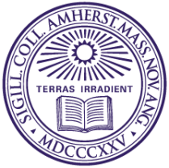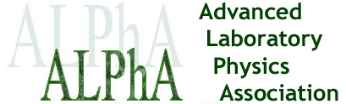

ALPhA 2017 New England Regional Meeting Overview

WHEN: 9 AM– 6 PM, June 14th, 2017

WHERE: Piano Lecture Hall, Beneski Building, Amherst College
11 Barrett Hill Drive
Amherst, MA 01002-5000

WHO: You! This is a conference for instructors, faculty, staff, and industry partners interested in Advanced Physics Laboratories beyond the first year in undergrad.

WHAT: This Regional ALPhA Conference has three goals:

1) Networking. To facilitate networking and cooperation among Advanced Lab folks in New England. Come and meet others interested in improving labs, get ideas, and local help implementing them.

2) Hands-on Experience. There are workshops and tours that participants can sign up to do. These get everyone in the lab doing an experiment or set of experiments. This is a fun way to get ideas or try something new.

3) Latest News. Come hear three speakers update our Region on things happening related to the Advanced Lab. Topics range from first-hand lab experiences to implementation of new teaching styles.

Participation is limited to the first 30 registrants. No registration fee. Lunch and dinner will be provided. Details and full schedule will be emailed to participants after registration.

To Register: Go to https://www.amherst.edu/academiclife/departments/physics/conference and register. Once you register, we will then email you a confirmation with detailed logistical instructions for the conference including parking and housing.

